How Naive Bayes Works
First, I’m going to walk through the theory behind Naive Bayes, and then solidify these concepts with an example to make it easier to understand.
The Naive Bayes Classifier is inspired by Bayes Theorem which states the following equation:

This equation can be rewritten using X (input variables) and y (output variable) to make it easier to understand. In plain English, this equation is solving for the probability of y given input features X.

Because of the naive assumption (hence the name) that variables are independent given the class, we can rewrite P(X|y) as follows:

Also, since we are solving for y, P(X) is a constant which means that we can remove it from the equation and introduce a proportionality. This leads us to the following equation:
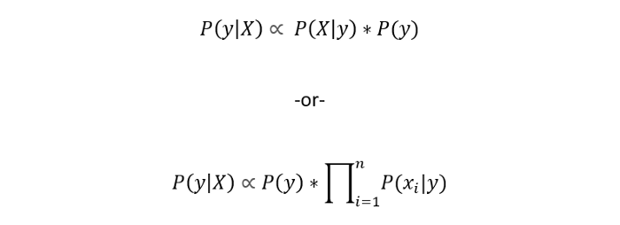
Now that we’ve arrived at this equation, the goal of Naive Bayes is to choose the class y with the maximum probability. Argmax is simply an operation that finds the argument that gives the maximum value from a target function. In this case, we want to find the maximum y value.

Now let’s go through an example so that you can make more sense out of this algorithm.

Example of Naive Bayes
Suppose you tracked the weather conditions for 14 days and based on the weather conditions, you decided whether to play golf or not play golf.
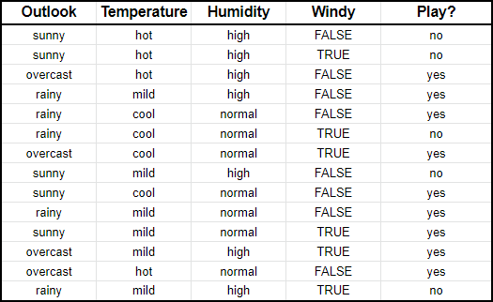
First, we need to convert this into a frequency table, so that we can get the values of P(X|y) and P(X). Recall that we are solving for P(y|X):

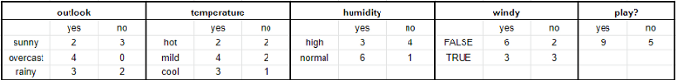
Second, we want to convert the frequencies into ratios or conditional probabilities:
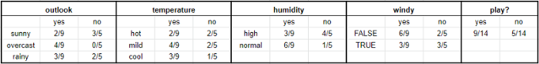
Finally, we can use the proportionality equation to predict y, given X.
Imagine that X = {outlook: sunny, temperature: mild, humidity: normal, windy: false}.
First, we’ll calculate the probability that you will play golf given X, P(yes|X) followed by the probability that you won’t play golf given X, P(no|X).
Using the chart above, we can get the following information:
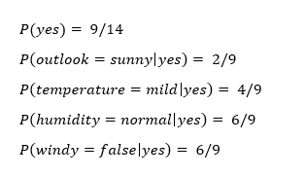
Thank you guys for the comments. I’ve made the correction above.
Now we can simply input this information into the following formula:
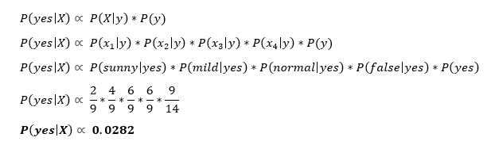
Similarly, you would complete the same sequence of steps for P(no|X).
Since P(yes|X) > P(no|X), then you can predict that this person would play golf given that the outlook is sunny, the temperature is mild, the humidity is normal and it’s not windy.

